R data structures

Maulid Hussein Bwabo

2022-11-04

# Preview of R data Structures

## Introduction

R encompass various data structures, at this point, we will discuss the frequent used structures in R that is more influential for data analytics. Here, we will illustrate some of the meaningful examples regarding to the data structures. This overview of the data structures give highlight of syntax and semantics of how R works. Indeed, the preview of data structure dive deep in telling the story about Vector, List, strings, and matrices. ## R Object R comprised of the five atomic object to run smoothly. The character, numeric(real number), integer, complex and logical(TRUE/FALSE). The most used object in the R programming is vectors. The R object has its own set with regard to attributes, these are alternatively branded as a metadata to the object. Of course, the metadata explain the object in R. Detailing out examples of the attributes in R important before describing the data structures in R. That said, the R attributes contain dimensions (matrices or arrays), class(integer or numeric), length, and dimensions names.

### Vectors

The heart of R programming is vectors, to make a deeply interaction with the R session, the vectors are the workhorse in the R environment. In fact, the vector normally works very well in R session if analysts managed to program in a same mode. (c) is the function used to create vectors objects and concatenating all the staffs in one pack.

x<-8  
x

## [1] 8

The above example demonstrated different types of vector underscored by attributes.For example, [1] show the row number begin with 1, R treat X as vector, vector with one element. ### Character strings R has the capability to manipulate the character strings, in fact, character strings are the are single elements vector in a character mode.

x<-c(1,2,3,4)  
x

## [1] 1 2 3 4

length(x)

## [1] 4

mode(x)

## [1] "numeric"

y<-"abc"  
length(y)

## [1] 1

mode(y)

## [1] "character"

Regarding the two example above R has the function to manipulate the strings, in the first example we created the vector as the numeric while the second we exercised one string vector.

u<-paste("abc","de", "f")#concatenating the strings  
u

## [1] "abc de f"

v <- strsplit(u," ") # split the string according to blanks  
v

## [[1]]  
## [1] "abc" "de" "f"

### Matrices

R matrix correspond to the maths that has the same name, these are the rectangular arrays number. To build the conceptual model in PLS-PM in R, matrix is the workhorse. In a technical tersm, matrix is the vector.

m <- rbind(c(1,4),c(2,2))  
m

## [,1] [,2]  
## [1,] 1 4  
## [2,] 2 2

m1 <- matrix(1:6, nrow = 2, ncol = 3)  
m1

## [,1] [,2] [,3]  
## [1,] 1 3 5  
## [2,] 2 4 6

From the above two example, we created two separate vector, we created matrix using the rbind function and the latter, the matrix function. The rbind stand for row bind function that used to build the matrix from the two separate vectors. At the same time, the cbind stand for combine several column to develop the matrix. The second example we created the m1 as matrix and pass it to the matrix functions by naming the number of rows as well as the column. ### List List is similar to vectors in R programming, but its contents poses different data types. To be more precise, the lists posit different classes, in that sense, the so-called “apply” functions are embedded in a list.

x1<-list(1, "ab", TRUE,1+4i)  
x1

## [[1]]  
## [1] 1  
##   
## [[2]]  
## [1] "ab"  
##   
## [[3]]  
## [1] TRUE  
##   
## [[4]]  
## [1] 1+4i

Next, we created a list with the vector.

x2<-vector("list", length = 8)  
x2

## [[1]]  
## NULL  
##   
## [[2]]  
## NULL  
##   
## [[3]]  
## NULL  
##   
## [[4]]  
## NULL  
##   
## [[5]]  
## NULL  
##   
## [[6]]  
## NULL  
##   
## [[7]]  
## NULL  
##   
## [[8]]  
## NULL

hist(Nile)

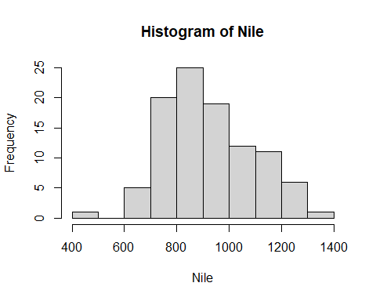 We used the ready made data set that available in R to exercised how the above data structures in R works.The data set called the Nile River Data sets.

hn<-hist(Nile)



print(hn)

## $breaks  
## [1] 400 500 600 700 800 900 1000 1100 1200 1300 1400  
##   
## $counts  
## [1] 1 0 5 20 25 19 12 11 6 1  
##   
## $density  
## [1] 0.0001 0.0000 0.0005 0.0020 0.0025 0.0019 0.0012 0.0011 0.0006 0.0001  
##   
## $mids  
## [1] 450 550 650 750 850 950 1050 1150 1250 1350  
##   
## $xname  
## [1] "Nile"  
##   
## $equidist  
## [1] TRUE  
##   
## attr(,"class")  
## [1] "histogram"

str(hn)

## List of 6  
## $ breaks : int [1:11] 400 500 600 700 800 900 1000 1100 1200 1300 ...  
## $ counts : int [1:10] 1 0 5 20 25 19 12 11 6 1  
## $ density : num [1:10] 0.0001 0 0.0005 0.002 0.0025 0.0019 0.0012 0.0011 0.0006 0.0001  
## $ mids : num [1:10] 450 550 650 750 850 950 1050 1150 1250 1350  
## $ xname : chr "Nile"  
## $ equidist: logi TRUE  
## - attr(*, "class")= chr "histogram"

head(hn)

## $breaks  
## [1] 400 500 600 700 800 900 1000 1100 1200 1300 1400  
##   
## $counts  
## [1] 1 0 5 20 25 19 12 11 6 1  
##   
## $density  
## [1] 0.0001 0.0000 0.0005 0.0020 0.0025 0.0019 0.0012 0.0011 0.0006 0.0001  
##   
## $mids  
## [1] 450 550 650 750 850 950 1050 1150 1250 1350  
##   
## $xname  
## [1] "Nile"  
##   
## $equidist  
## [1] TRUE

class(hn)

## [1] "histogram"